**PPG Hand Out**

**November 2018**

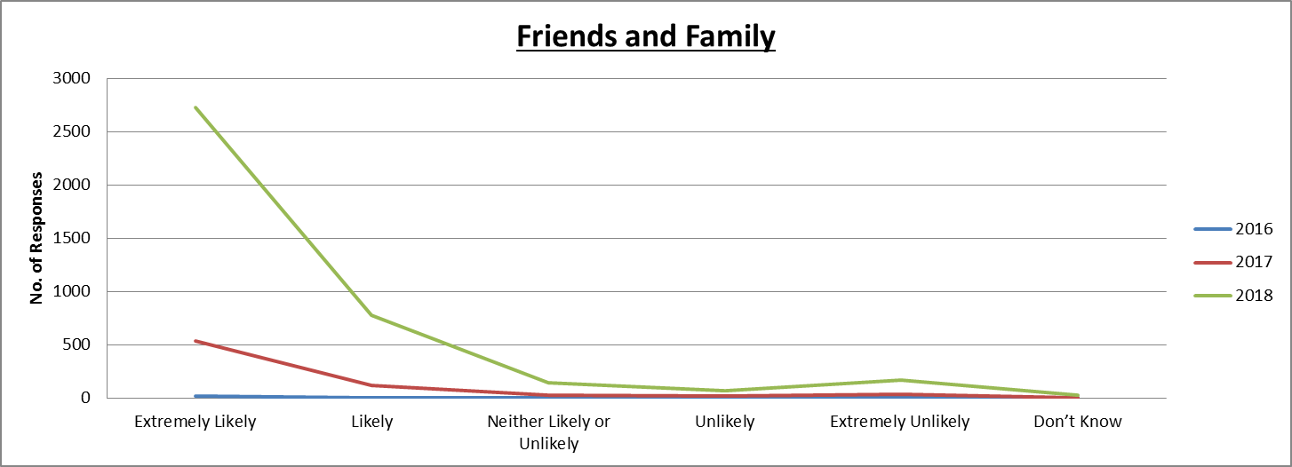

|  |  |  |  |  |  |  |
| --- | --- | --- | --- | --- | --- | --- |
|  | **Extremely Likely** | **Likely** | **Neither Likely or Unlikely** | **Unlikely** | **Extremely Unlikely** | **Don’t Know** |
| **2016** | 16 | 7 | 2 | 2 | 1 | 0 |
| **2017** | 537 | 118 | 32 | 20 | 33 | 7 |
| **2018** | 2728 | 778 | 148 | 66 | 170 | 28 |

